Status on the Multi-conjugate adaptive optics system on 1m New Vacuum Solar Telescope
Lanqiang Zhang^{1,2,3, a}, Xuejun Rao^{1,2}, Hua Bao^{1,2}, Youming Guo^{1,2,3}, Xian Ran^{1,2,3,} Nanfei Yan^{1,2,3}, Libo Zhong^{1,2,3}, Jinsheng Yang^{1,2,3}, Cheng Wang^{1,2}, Xinlong Fan^{1,2,3}, Mei Li^{1,2}, Xiaojun Zhang^{1,2}, Ningping Shi^{1,2}, Donghong Chen^{1,2,} Zhongyi Feng^{1,2} and Changhui Rao^{1,2,3, b}
1The Key Laboratory of Adaptive Optics, Chinese Academy of Sciences, Chengdu 610209, China
2Institute of Optics and Electronics, Chinese Academy of Sciences, Chengdu 610209, China
3University of Chinese Academy of Sciences, No.19A Yuquan Road, Beijing 100049, China
ªlqzhang@ioe.ac.cn, ^{b}chrao@ioe.ac.cn,

Abstract:

A multi-conjugate adaptive optics (MCAO) system was designed as a new instrument of the 1-meter New Vacuum Solar Telescope (NVST) for routine scientific observation in 2017. This system, which includes one tip/tilt mirror, three deformable mirrors, and two multi-direction wavefront sensors, has been mounted on the telescope and tested for more than one year. The new MCAO configuration, that is, high order ground layer adaptive optics (GLAO) combined with low-order high altitude correction, was adopted for the expected effect of high-resolution correction imaging in 1 arcmin field of view. The opto-mechanical design allows for changing the conjugate plane of the two high-altitude DMs independently between two and ten kilometers. The control system is based on Multi-core CPUs platform, which is flexible for testing various control approaches. In this paper we present the integration testing and some of the first experimental results, on the basis of a brief system introduction. The observed results with GLAO close are well, while the MCAO system is under improved for better results.

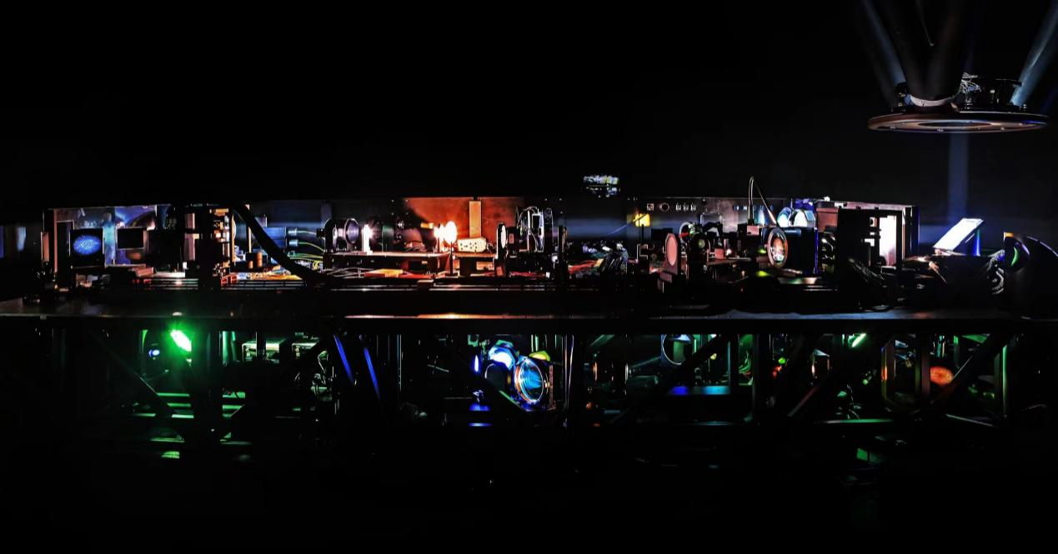
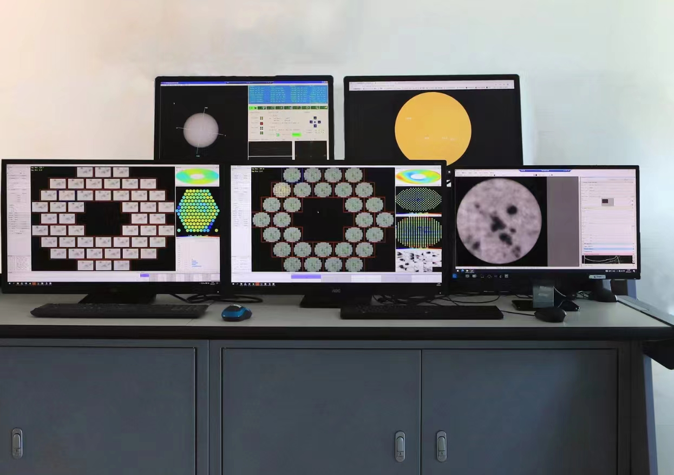
Fig. 1. The photos of the MCAO system at work.

Key words: multi-conjugate adaptive optics (MCAO), multi-direction Shack-Hartmann wavefront sensor, NVST, solar observation

