The progressive simulations for solar multi-conjugate adaptive optics on 1m New Vacuum Solar Telescope

Zibo Ke^{1,2}, Lanqiang Zhang^{1,2} and Changhui Rao^{1,2,b}
1The Key Laboratory of Adaptive Optics, Chinese Academy of Sciences, Chengdu 610209, China
2Institute of Optics and Electronics, Chinese Academy of Sciences, Chengdu 610209, China
ªkezibo@ioe.ac.cn, ^{b}chrao@ioe.ac.cn,

Multi-conjugate adaptive optics (MCAO) is one of the most promising techniques currently developed to enlarge the corrected field of view (FoV) of adaptive optics in astronomy. The typical configuration in solar MCAO system often consists of two components: the first is an AO system that uses an on-axis wavefront sensor (OAWFS) and a deformable mirror (DM) conjugated at 0 km to correct the low altitude turbulence, the second is a high altitude part (HAC) that uses a multi direction wavefront sensor (MDWFS) to measure the high altitude turbulence under large FoV, and N(N≥1) DMs are conjugated at corresponding atmospheric layers to correct the residual aberrations from the former AO system. As a result, by performing high-order low altitude and low-order high altitude [AO + HAC] correction, such a MCAO system can achieve multi layers correction with a large FoV while also reducing system costs. However, because the ground layer correction based on OAWFS only benefits on-axis direction but penalizes off-axis direction due to anisoplanatic error, the correction effect is typically non-uniform, leading to an obvious issue in solar MCAO: only the central FoV can acquire good quality.
In order to overcome the FoV inconsistency, a new configuration of solar MCAO has been proposed and constructed in the 1-meter New Vacuum Solar Telescope (NVST): An GLAO part with an individual high-order MDWFS is employed to replace the conventional AO part to detect the ground layer turbulence for low altitude correction. Similarly, low-order MDWFS provides the wavefront information caused by high layers turbulence through atmospheric tomography for high altitude correction [GLAO + HAC]. In this paper, for the purpose of comparison verification and parameters optimization of the real system, we make both the zonal and modal close loop simulations for various configurations based on object oriented matlab adaptive optics toolbox (OOMAO), including the conventional AO, the GLAO, and the MCAO with the AO + HAC and the GLAO + HAC architectures. The results show that the correction uniform and performance of the new scheme is obviously improved compared to conventional solar MCAO configuration. Furthermore, the system’s detailed error budget and trade-off study are still being worked on.

Key words: MCAO, NVST, simulation, system optimization.
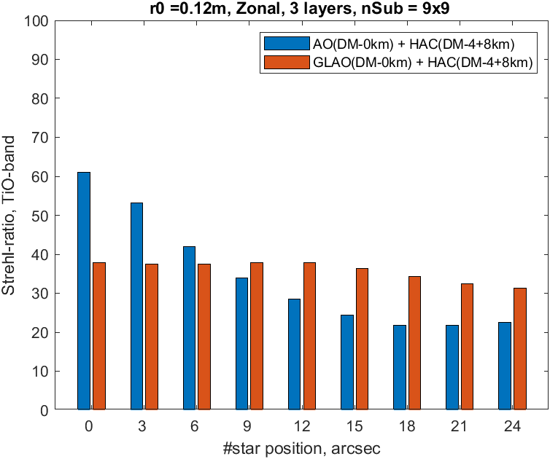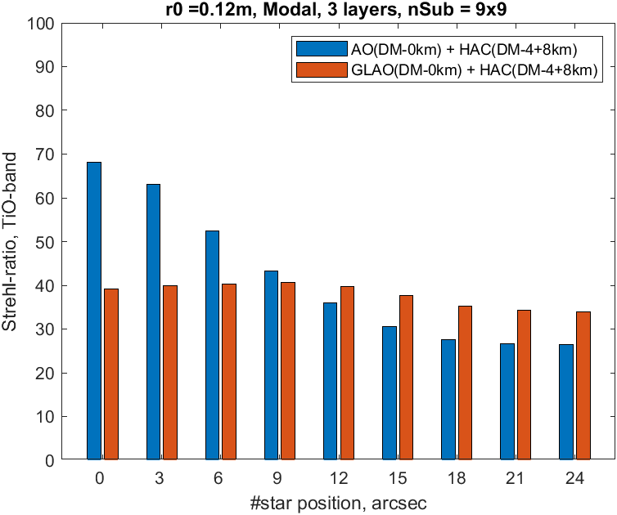
Fig 1. The zonal and modal close loop simulation comparison between AO+HAC and GLAO+HAC. Left: zonal method, Right: modal method. FoV enlarges from center(0 arcsec) to edge(24 arcsec)

